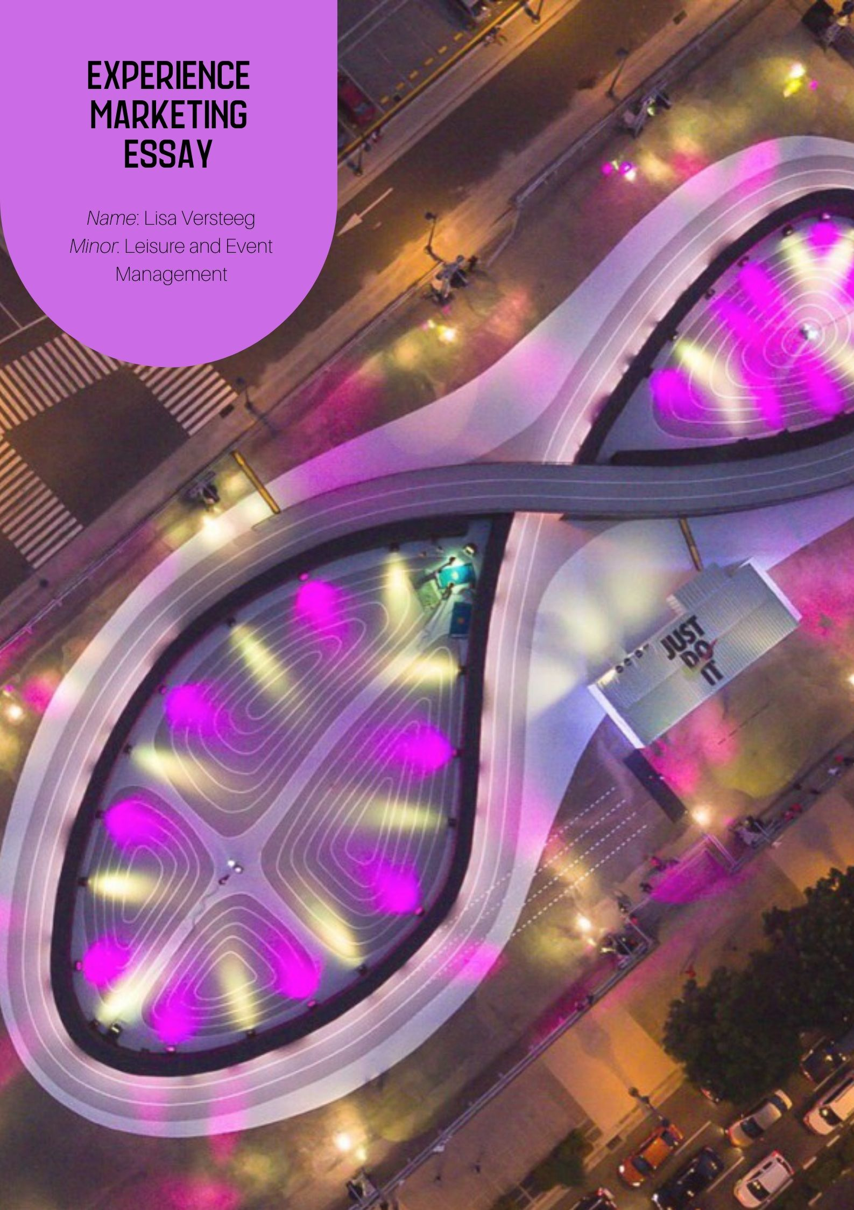

**Essay – Experience Marketing**

Table of content

Introduction 3

Creative approach of marketing 4

Evolving experience marketing 4

Improving customer satisfaction and loyalty 5

Trends in Experience Marketing 5

Experience marketing in event and leisure sector 7

15-01-2020

# Introduction

In this essay experience marketing and the importance of it will be explained. The following question will be answered: ‘’How did the Experience Economy evolve and what effects will this concept have on organizations and customers (especially in the Leisure & Event Sector) in the future? Why is Experience Marketing so interesting to the Leisure & Event Sector?”

When I was in Berlin last summer I had a really nice experience at a Pizza restaurant. Me and my friend came here by accident. On the outside it looked like a take away and not that catered.

But since we were really hungry, we gave it a try. We found out that next to the window, where you could take pizza’s, there was a door. When we opened the door, we suddenly entered a whole different world. We were very surprised. The floor was sand with wood boards and there were all kind of cozy seats throughout this garden. Yes, a garden. There were some trees inside and there was no roof. But because of the cozy ambiance it felt like you were inside. It was not very big. On our left there was a turning table with a DJ playing disco/techno sounds. The music was very nice. In front of the DJ there was a little place to dance. On the right there were some big red vintage chairs and fences by tree with little lights in it. People were chatting, eating pizza and dancing to the music. When we walked through this place, we arrived at the Pizza corner. There were 2 Italian guys baking pizza in a brick oven. So we ordered our pizza and took a nice seat to enjoy our amazing dinner in this amazing place. Like most urban places in Berlin, there are not much pictures to find inside. This is what makes the experience even bigger. Because you don’t know before what to expect, it will all become a nice surprise when you get in.

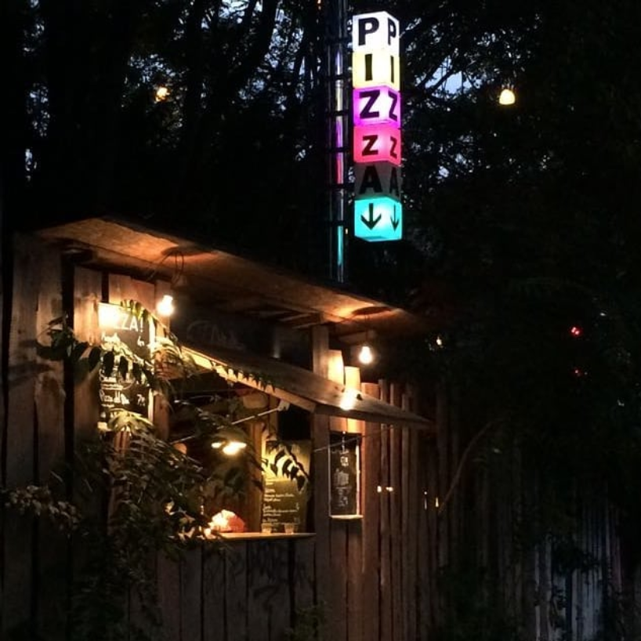

Why this pizza restaurant was so great was really not based on the food. Although the pizzas tasted very good. You can get brick oven pizza’s anywhere but at this place it was all about the experience. The music, lights, decoration and the happy people took care of the great atmosphere. Therefore, it is important for restaurants to think about these aspects.

# Creative approach of marketing

Experience marketing is a creative approach of marketing. This type of marketing is getting more important every year. Brand experience is an important expect when it comes to building a relationship between customer and brands. Knowing how powerful experiences can be in order to improve customer relationships, marketers host experimental marketing events to help companies build these connections with their audience (Tatulli, 2019). Experiences help forming emotional connections. In addition, customers believe that brands should use their voice to be a force of good for social and ethical issues. In that way you will give something back to the society. It is a great way to not only engage your audience, but also help others (Tatulli, 2019).

# Evolving experience marketing

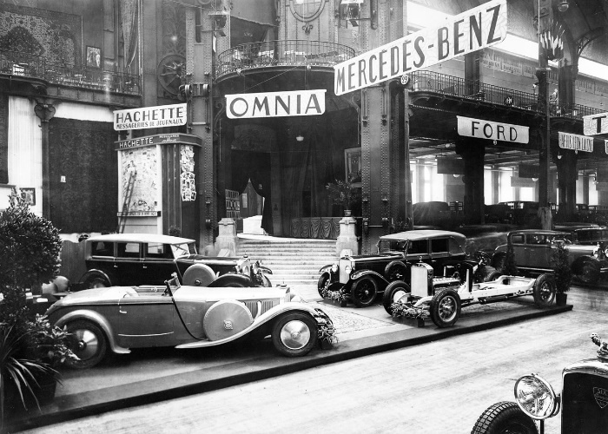World Fairs and Car shows were the first types of experience marketing, started from 1920. These fairs and shows were not only about buying products but also about experiencing the products (“The History of Experiential Marketing,” 2017).   
  
In 1983 the first guerrilla marketing was used. Consumers were surprised with products or services in an unexpected place which created a memorable experience for them. Brands saw that it worked and by the late 1990s, guerrilla marketing was a big thing.   
  
In 1998, a book named The Experience Economy, stated that people would pay more for products if it came along with an experience (“The History of Experiential Marketing,” 2017). In this time marketing was evolving because of the technology. The rise of social media made marketers reach a big public. They could invite everyone trough social media for their events. Social media is also used to communicate event information, to enlist influencers, for general goodwill, to build a database and to make special offers (Moderne Communications, 2014). Therefore, social media was an important evolvement for experience marketing.

Most used forms of experience marketing that started in 2000 were immersive brand experiences. Brands were present at big shows like the Super Bowl, Comic-con and Coachella. This allowed consumers to experience the brand through various elements like games and activities, digital elements and virtual reality. Another popular form for experience marketing were pop-up events. Especially for brick and mortar retailers, online shops and corporations. It gave them the opportunity to showcase their products or services for a short time (Staffing, 2018).

Nowadays, data collection is a matter. Customers know that their personal information is collected to make targeted marketing. One-on-one interaction such as experience marketing is therefore even more valuable. Clients' motivation is measured by observation and not by assembling a collection of unrelated search and click data (Manoukian, 2018).

# Improving customer satisfaction and loyalty

There are many definitions for ‘Experience Marketing’. The most important aspect of experience marketing is creating a meaningful relationship between the brand and customer. You can accomplish this by involving customers in your brand. Customers are interested in the brands they buy. Therefore, it is important to be loyal, transparent and give customers the availability to experience the brand with all senses. A survey, made by Experiential Marketing News, show that over 65% of consumers prefer experiential to every other form of marketing. People are also more likely to buy a new product if they can try it first.

In addition, consumers are changing their values and sensibilities. They value meaningful engagement and transparency. As said before, they are interested in brands. They want to know where their money goes to and what the thought behind the company is (Cavanaugh, 2019).

Experience marketing give the brand an opportunity to humanize and tell its story. This story is transparent, engaging and gives people an insight. The brand has to determine the inspiration behind the brand and what they want customers to feel. Emotions are a strong call to action (Cavanaugh, 2019).

# Trends in Experience Marketing

Technology has been a trend from the beginning of experience marketing. It makes it possible to drive connections between the brand and its audience. Technology can be used in various ways. Event management software platforms are essential to experiential marketers’ strategies (K. Tatulli, 2019). Besides, there are other trends like:

1. Ticketing
2. Instagrammable settings
3. Personalization
4. 5 sense engagement
5. Self-care
6. Big Data

*Ticketing*  
Most events for experiential marketing are free, but research has shown that one-third of the visitors would pay a ticket fee to enter a brand event. Therefore, ticketing you event can beneficial the brand and the audience. With the funds of the fee, the event can be more elaborate and better the experience (K. Tatulli, 2019). It can also feel more exclusive for the visitor when they have obtained a ticket and another person could not anymore.

*Instagrammable settings*  
Due to the many influencers, sharing amazing pictures of places you visit become more popular. People want to show their followers what kind of amazing place they found. Most of the new restaurants have this instagrammable interior. It creates a further buzz around your brand. Therefore, experiences should have this instagrammable feeling (K. Tatulli, 2019). People will share it on their Instagram, which creates more attention for your brand. You can also invite influencers to your event. They will share their experiences with many followers.

Ways to make your event instragammable, is by having a backdrop. This backdrop can come in every style. People like to take photos in front of a backdrop. In addition, good lights are important for good photos. Also unique artworks our funny furniture for example, will desire people to make photos. To create even more buzz and content, you can have an online giveaway for people that share their photos and use your hashtag.

*Personalization*  
Personalization is a trend for a long time in every way of marketing. It is important to make it greater in experiences. Customers should have the feeling that it is really about them. When customers register online, you will receive information. Use this in your event. Welcome them by their name for example. In addition, during register you can ask them about dietary needs and seating preferences. The customers will feel more connected to your event (K. Tatulli, 2019).

*5-sense engagement*To create the most memorable experience, use all 5 senses. With our senses we process the experience around us. Therefore, the experience should incorporate all the senses like sight, sound, touch, smells and tastings (K. Tatulli, 2019). Example are lightshows on music in a room with walls of different textures. Tasty snacks with a delicious smell will be served.

*Self-care*  
Taking good care of yourself, your health and your body is super popular. People are into more sports than ever and try healthy diets that are good for the environment as well. Offering talks about a balanced life, healthy food and yoga are a nice addition to your event (K. Tatulli, 2019). In addition, you can create some chill-outs spots in a cozy atmosphere. Fill a room with lots of pillows, dark colors, nice smell and healthy herbal tea for a relaxed feeling. An experience like this will also obtain the 5 senses.

*Big Data*Big data is the key trend to create a personal experience, be loyal and connect customers to your brand. It will also improve future events. Event management technology can easily capture big data and make statistics to understand your target group (K. Tatulli, 2019).

# Experience marketing in event and leisure sector

Events and the leisure sector are already an experience on their own. To clarify ‘leisure’, research agency Dynamic Concepts distinguish 3 types of leisure.

1. Slow leisure is about consciously enjoying the environment in while you perform an activity. The activity is not the core, the enjoyment is. Examples are swimming, visiting a spa, walking or go to the woods (Vermeulen, 2019).
2. Experience leisure is about being actively involved in the experience of an activity. Examples are going to a theme park, watersports, party’s/festivals, going to a sport competition, casino and going to the cinema (Vermeulen, 2019).
3. Urban leisure is about being passively involved in the activity or being included in the experience. The participant has little or no influence on changing elements. Examples are visiting a theater, watching an exhibition, museum or a restaurant (Vermeulen, 2019)

In my opinion, all of these general leisure activities can be turned into an unforgettable experience. With regard to urban leisure, I think you can ensure that participants have an influence here. The so called ‘experience-museums’ are growing due to the popularity. These museums are not only enjoyable, they are also instagrammable. People here can touch things, do things, hear, smell, taste and see. Therefore, these are the perfect types for an unforgettable 5-sense experience.

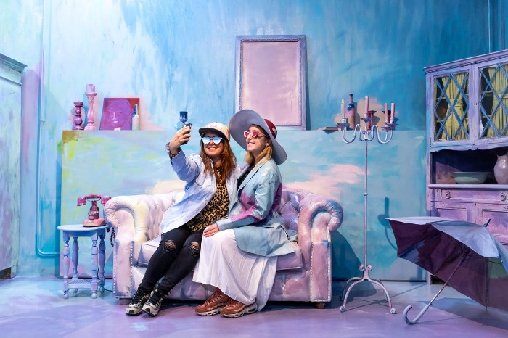A couple of experience museums:  
- Wondr Amsterdam  
- Youseum Amsterdam  
- Moco museum Amsterdam  
- Museum of ice cream New York  
- Borderless Tokyo

Wondr-museum Amsterdam is the perfect place for Instagram photos, according to news sites. Wondr is also called the artistic playground of Amsterdam. There are 15 different rooms, all very photogenic. The purpose is to let people be a part of the art. When a person enters a room, they are involved in the ‘painting’. This makes it a perfect experience. Due to all the Instagram photos that visitors post, the museum became very popular. However, people will not visit it twice if they have the perfect pictures already.

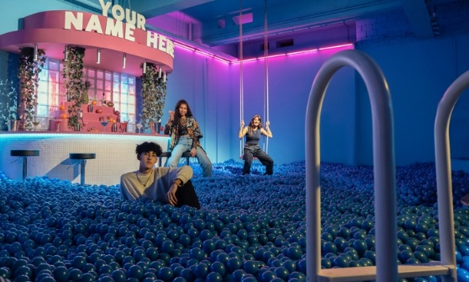Youmuseum, also in Amsterdam, has sort of the same concept as Wondr. It is mix of a pop-up art experience and an Instagram museum. Museums like these are targeted at the ‘social media generation’. In this museum they create attention for matters like plastic pollution and gender equality.

In New York they have the Ice Cream museum. In Tokyo they have an experience museum called Borderless. They all look a bit the same. So I think they should be more outstanding to still be popular. If you visit one of these, you have seen enough of it already I think. But it is a nice upcoming trend to make museums where you can participate in the art. It is also a good way to give attention to social issues.References:

Cavanaugh, C. (2019, January 9). Why Brand Experience Is the Future of Marketing — Part One. Retrieved January 13, 2020, from <https://www.freeman.com/insights/why-brand-experience-is-the-future-of-marketing-part-one>

Moderne Communications. (2014). *Experiantal Marketing Trends*. Retrieved from <https://cdn2.hubspot.net/hub/197385/file-491584129-pdf/docs/experiential_marketing_trends_2014_moderne_communications.pdf>

Manoukian, J. (2018, December 12). 4 Key Trends Driving the Evolution of Experiential Marketing. Retrieved January 12, 2020, from <https://www.limelightplatform.com/blog/trends-evolution-experiential-marketing>

Staffing, A. E. (2018, June 14). The Evolution of Experiential Marketing. Retrieved January 12, 2020, from https://atneventstaffing.com/evolution-of-experiential-marketing/

The History of Experiential Marketing. (2017, June 2). Retrieved January 12, 2020, from <https://factory360.com/the-history-present-and-future-of-experiential-marketing/>

Tatulli, K. (2019, July 26). 9 Trends Driving Experiential Marketing in 2019. Retrieved November 29, 2019, from <https://www.aventri.com/blog/9-trends-driving-experiential-marketing-in-2019>

Vermeulen, T. (2019, February). Waar liggen kansen in de vrijetijdssector? | nrit.nl - trends, nieuws en kennis op het gebied van leisure, toerisme en hospitality. Retrieved January 14, 2020, from https://www.nritmedia.nl/kennisbank/40792/waar-liggen-kansen-in-de-vrijetijdssector/?topicsid=